BACHELOR THESIS

Term thesis submitted in partial fulfillment of the requirements for the degree of Bachelor of Science in Engineering at the University of Applied Sciences Technikum Wien - Degree Program Electronics and Business

**Smoke Detector Interconnection for**

**Smart Home Environments**

Conducted from: Bernhard Erös

Personal identifier: 1810255057

1. supervisor: Alija Sabic, MSc.

Vienna, 2020-05-12

Declaration of Authenticity

“As author and creator of this work at hand, I confirm and acknowledge with my signature any relevant copyright regulations governed by creator and higher education acts (cf. copyright law and furthermore Statute on Studies Act Provisions / Examination Regulations of the UAS Technikum Wien within the framework of existing legislations).

I hereby declare, this thesis is my own personal work and any ideas of others or sources are used and cited accordingly. I am aware to face consequences declared by the head of the degree program, if I am not able to proof evidence, autonomy or independence or fraud to achieve a positive grade for this work (cf. Statute on Studies Act Provisions / Examination Regulations of the UAS Technikum Wien within the framework of existing legislations).

Furthermore, I declare this work has not been published to this date nor have I submitted it in this or any other form to an examination board. I assure this submitted version matches the version in the upload tool.”

|  |  |  |
| --- | --- | --- |
|  |  |  |
| Place, Date |  | Signature |

Kurzfassung

Rauchmelder haben zahlreiche Leben seit ihrer Einführung für kommerzielle Nutzung vor 60 Jahren gerettet. In den letzten Jahren wurden Regelungen für Rauchmelder für private Haushalte zur verpflichtenden Montage geschaffen oder sie werden vermehrt freiwillig montiert bzw. installiert. Dennoch bietet der Großteil dieser Melder keine Option für eine Integration in Smart Home Umgebungen. Eine stabile und verlässliche Verbindung zwischen Melder und beispielsweise einem Smartphone eines Nutzers bietet Komfort als auch Sicherheit. Typischerweise werden diese Aspekte mit hohen Anschaffungskosten von potenziellen Konsumenten verbunden. Zu Beginn dieser Arbeit werden Brandmelder nach Stand der Technik anhand ihrer Prinzipien und Einsatzgebieten sorgfältig beleuchtet und verglichen. Nach dieser Recherche wird als Teil dieser Arbeit ein Prototyp entworfen, welcher einen kostengünstigen konventionellen Melder als Basis für diese Integration nutzt. Das Ziel dieser Implementierung ist die erfolgreiche Vernetzung zwischen einem Melder und einem *Tessel 2 Mikrocontroller* (T2). Eingehende und ausgehende Signale zum Rauchmelder selbst werden dabei vom Tessel 2 übertragen und verarbeitet. Dieser Mikrocontroller basiert auf JavaScript. Im realisierten Prototyp läuft ein Webserver mit einer entwickelten Webpräsenz. Diese Webpräsenz zeigt Nutzern einen anstehenden Rauchalarm an und ob sich der Rauchmelder noch in Betrieb befindet. Die eingebaute Testfunktion des Melders ist auch in dieser Webpräsenz implementiert, um diese ferngesteuert innerhalb eines privaten Heimnetzwerks auszulösen.

Abstract

Smoke detectors saved many lives after their commercial introduction around 60 years ago. In recent years, smoke detectors for private households have become either mandatory by regulations or are installed more and more voluntarily. However, a vast majority of these detectors lack an option for integration into smart home environments. A steady and reliable connection between a detector and a user’s smartphone for instance means comfort and safety. Typically, these aspects are associated with higher acquisition costs from possible customers. Prior in this thesis, existing state of the art smoke detectors are thoroughly examined based on their principles and fields of application. After this research, as part of this thesis, a prototype is designed which utilizes a low-cost conventional smoke detector as foundation for this integration. The aim of this implementation is a successful interconnection between the detector and a *Tessel 2 microcontroller* (T2). Incoming and outgoing signals from the detector itself are transferred and handled by the Tessel 2. This microcontroller is based on JavaScript. The realized prototype hosts a dedicated webserver with a developed web presence. This web presence displays users a pending smoke alarm and if the smoke detector is still in operation. The detector’s built-in test function is also implemented in this web presence, to trigger it remotely within a private home network.

Table of Contents

1 Introduction 7

1.1 Problem Definition 8

1.2 Aim of this Work 8

1.3 Personal Motivation 8

1.4 Methodological Approach 9

1.5 Structure of this Thesis 9

2 Technical Fundamentals 10

2.1 Smoke detector types and principles 10

2.1.1 Factors affecting smoke detection 10

2.1.2 Ionization smoke detectors 11

2.1.3 Photoelectric smoke detectors 11

2.1.4 Heat detectors 12

2.1.5 Carbon Monoxide detectors 13

2.1.6 Multiple sensor detectors 13

2.1.7 Aspirating smoke detector systems 14

2.1.8 Linear detectors 16

2.1.9 Wireless smoke detectors 16

2.1.10 Smoke detectors for home use 17

3 Web Development 18

3.1 Hypertext Markup Language 5 (HTML5) 18

3.2 Cascading Style Sheets (CSS) 18

3.3 JavaScript 18

3.4 Node.js 19

3.5 Hypertext Transfer Protocol (HTTP) 19

3.6 Transmission Control Protocol (TCP) 19

4 Design Specifications 20

4.1 Functional Requirements 20

4.2 Nonfunctional Requirements 20

5 Prototype Design 21

5.1 Concept 21

5.2 Architecture 21

5.3 Hardware 21

5.3.1 Smoke detector 22

5.3.2 Tessel 2 23

5.4 Software 23

6 Technical Implementation 25

6.1 Initial Setup for Tessel 2 25

6.2 Input and Output Processing 26

6.3 Smoke Alarm and Flash LED 27

6.4 Test Function 28

6.5 Client Application 30

6.6 Webserver Configuration 30

6.7 Prototype 31

7 Results and Discussion 32

7.1 Results 32

7.2 Reliability & Security 32

7.3 Costs & Market Situation 32

7.4 Future Advancements & Outlook 33

8 Summary 34

References 35

List of Figures 41

List of Tables 42

List of Listings 43

List of Abbreviations 44

# Introduction

With the introduction of smoke alarm detectors for commercial use in the early 1950’s [1] and for residential use around the 1970’s this market is still growing and an interesting market to date [2]. First, smoke detectors were used for the military facilities, warehouses or public buildings built by the government, in order to meet prevalent safety standards. They were not sold to the public until a significant price drop of smoke detectors due to technical developments was achieved. One of the most important developments was the introduction of solid-state electronics [3]. Namely diodes, transistors and integrated circuits, which replaced the predominant technology with its cold cathode tubes or vacuum tubes. This allowed manufactures to reduce manufacturing and resource costs and eventually mass-produce these devices to sell them for reasonable prices to customers. From this moment on, the whole industry started to gain momentum and further developments in terms of detection of smoke, size of detectors, energy efficiency or to connect multiple detectors to fire alarm systems with steady connections to fire brigades. These allowed for faster and reliable detection of fire and for prompter alerting of people inside buildings or structures where these fire alarm systems were installed. Smoke detectors operated by batteries were introduced for customers to provide easier installment and without the necessity of expensive fire alarm systems.

According to a survey of *National Fire Protection Association* (NFPA) almost every private household, at around 96 Percent, in the *United States of America* (USA) has smoke detectors installed in their homes [4] [5]. All these smoke detectors have one major disadvantage: their battery. These must be exchanged at certain intervals or a renewal of the whole detector is advised according to manufacturer’s manuals to ensure proper functioning of the detector. In the *European Union* (EU) however, there is not such a dense distribution of smoke detectors in private households. This is due to higher and more uniform building codes across the EU which focus more on fire prevention instead of fire detection. Every building according to its designated use must withstand a certain time against fire or fire safety facilities are implemented. Whereas standards in the USA are lower or the they are not even adopted at all [6]. This means barely minimum fire safety requirements for new or existing buildings are met in the USA (most houses are built from wood because it is the cheapest resource in the USA). Fire safety regulations in Austria or Germany overachieve minimum fire safety standards of the EU. In Austria they are applied through several guidelines, e.g. “*Österreichisches Institut für Bautechnik*” (OIB) OIB Richtlinie 2 [7] and “*Technische Richtlinie Vorbeugender Brandschutz*” (TRVB) TRVB 122S [8]. In Germany there are similar guidelines, e.g. “*Deutsches Institut für Normung*“ (DIN) DIN 4102-1 or “*European Norm*” (EN) EN 13 501-1 [9].

Although there are many regulations to prevent fire, it is not totally impossible that fire occurs or ignites. Annual statics [9] show around 400 people die from fires worldwide, but only one third dies in the consequence to fire, the other two thirds die in the case of smoke intoxication. 4000 people worldwide suffer long-term damage from burnings and around 1 Billion Euro of fire loss is accumulated worldwide in private households. These figures tell us most people die from smoke not from the actual fire itself. Many of these victims are surprised at night and do not recognize the smoke or fire while sleeping. To reduce the casualties of smoke intoxication almost every manufacturer of home smoke detectors has integrated or combined sensors for smoke / heat or *carbon monoxide* (CO) detection, acoustic beepers or smart home implementations to receive notifications or simplified maintenance [10]. For example, when there are several smoke detectors in every room of a house installed, they create a mesh network. If there is an alarm, the detecting smoke detector transmits this signal to every other detector in this network and all acoustic beepers trigger at the same time to alert everyone in the house [11]. In Austria it is mandatory to install smoke detectors in habitable rooms or on exit paths in new or refurbished buildings since 2008 [7]. This does not imply, that the latest and greatest smart home detectors are installed in this new or refurbished buildings.

## Problem Definition

Ideally, every private household should install smoke detectors in their homes, to protect themselves from fire and the even more dangerous smoke caused by fire. But most people think, these are rather expensive, unreliable or are annoyed from changing batteries. This could lead to:

* losing their lives from smoke intoxication
* damaging or losing their property in the case of fire without insurance covering it
* or treat safety or fire prevention slightly and do not care

Today’s home smoke detectors are well-engineered, reliable, more user friendly then people would think of.

## Aim of this Work

The aim of this bachelor thesis is, to show how state of the art smoke detectors work and to point out principles of different detections for smoke or fire. This comparison amongst detectors builds a foundation, which type of detection is suited best for a detector prototype using the Tessel 2 microcontroller. An available cost-efficient smoke detector shall be connected to this microcontroller. Specifications for this prototype design are defined later in chapter 4. Furthermore, a website should be developed to display relevant information and the current status of the interconnected detector and microcontroller. This design is uploaded to a GitHub repository <https://github.com/ew18b057/Bachelorarbeit>.

## Personal Motivation

The topic fire safety is a vital part of my life, since I work as a field engineer for fire alarm systems for one of Austria’s leading companies for around ten years. During my working hours I check, maintain, program or install various kinds of smoke detectors or parts of our fire alarm systems for our diverse customers. Although there is a lot of routine work involved, because all parts work reliably, it is still a challenge for me to retain this high level of quality, our customers rely on. This high reliability of our products made me curious how different detectors or parts of our fire alarm systems are constructed and work. Also, many lives were saved because of smoke detectors. In fact, fire deaths were reduced by 50 Percent since the 1970s [12]. These thoughts motivated me, to design an appropriate smoke detector prototype and a corresponding website. This shall help to engage myself even more with the topic fire safety and to gain more in-depth knowledge of technical fundamentals behind it.

## Methodological Approach

At first, a theoretical research of current existing detecting methods, sensors and detectors for smoke and fire is conducted based on relevant literature or from hardware manufactures. Afterwards a brief section of web development is useful in order to choose an appropriate approach for the prototype detector design. This builds a foundation to build a suitable implementation with a chosen smoke detector and the Tessel 2. Concurrently, a web presence is programmed to showcase the function of the smoke detector, which should be easy to use and functional as well.

## Structure of this Thesis

This thesis is structured in eight chapters. Chapter 1 focuses mainly on introductory and background information, my personal motivation and the aim of this bachelor thesis. It also gives an overview of the approach to achieve this aim.

In the second chapter technical fundamentals of different smoke detector types are described. Also, ancillary information for home smoke detectors and regulations how they are appointed are mentioned. Chapter 3 briefly discusses various web development related topics, since these are needed for the realization of a functioning prototype.

The fourth chapter determines the specifications which the design, respectively the prototype must fulfill. In chapter 5 a concept for the realization is outlined. Its architecture and used hardware are also described. The technical implementation and the necessary steps for a successful realization are shown and described in chapter 6.

Chapter 7 provides results and shows if design specifications are met. It also covers supplementary information such as, reliability and security, costs and market situation, future advancements and which lessons were learned.

The last chapter concludes with achievements and findings.

# Technical Fundamentals

This chapter covers and provides relevant knowledge needed, to understand underlying principles of smoke detection.

## Smoke detector types and principles

The following sections illustrate the variety of relevant state of the art smoke detector types and their principles of smoke detection. Based upon their characteristics a suitable smoke detector is used for the prototype development.

### Factors affecting smoke detection

There are many different factors to be considered when smoke detectors are in use. But these four key factors [13] determine how well smoke is detected and affect detection the most.

The first factor is smoke itself. Every material burns differently. The size of particles and smoke density varies from material to material. Some materials produce larger particles when burned (e.g. plastics) or smoldering fires compared to flaming fires emit smaller particles.

Another factor is smoke entrance resistance i.e. how easy or hard it is for smoke to permeate into a detection chamber. If this resistance is too high (e.g. geometry or structure of a detector, or filters around the detection chamber are to narrow), this will affect the rate of smoke detection.

The rate of smoke buildup is factor three. Some materials burn faster than others based on their chemical structure itself [14]. Or for example smaller objects burn faster than larger objects (same material, same weight considered). Due to their increased surface area, more oxygen contributes to the oxidation process leading to an increased combustion process [15].

The last factor to be considered is the low propagation velocity of smoke (unless there are no vents or air supply active or nearby). Fast propagating smoke eases permeating into a detector’s chamber. Low velocity smoke could cool down to form larger particles i.e. there are less particles for detection and it takes smoke longer from the fire source to reach the detector.

Smoke detectors have different sensitivities based on their varying detection mechanisms and scopes to detect smoke particles.

### Ionization smoke detectors

These types of smoke detectors were the first to be developed, although their principle was discovered accidently around the 1930s. They were granted license for distribution in the 1960s [16]. For detection a small amount of radioactive material, *americium-241* (AM-241) is used. This material and two metal plates (positive and negative potential are applied to the plates) are located inside the detection chamber shown below in Figure 1. The radioactive material is present in the form of a thin foil between both plates. When no smoke is present within the detection chamber, AM-241 ionizes with surrounding air molecules to create a steady current flow between both plates. When smoke enters the chamber the ionization process with air is disrupted. AM-241 interacts with smoke particles instead of air molecules thus resulting into a current drop, which is evaluated for an alarm signal.

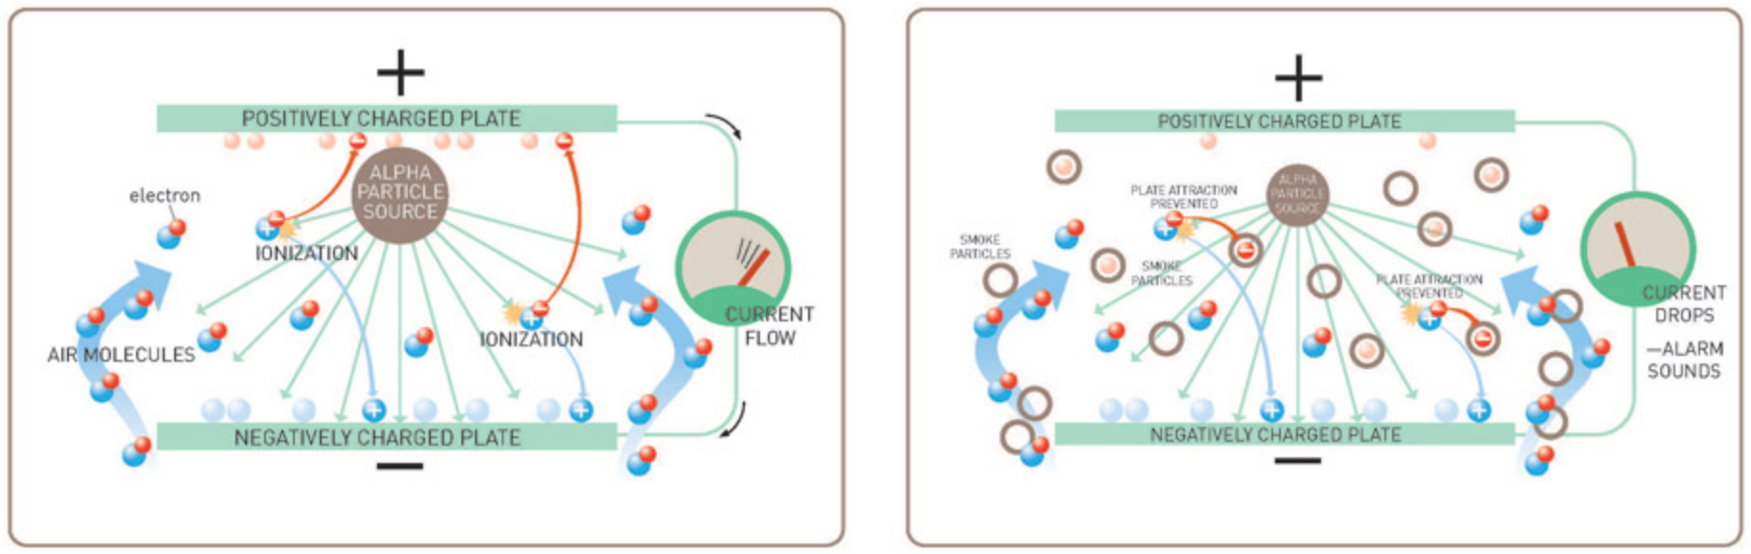

Figure 1: ionization principle [16]

Although radioactive material is used in these detector types, AM-241 is not hazardous (it emits alpha radiation which represents a threat when this material gets in the body only) [16]. In Germany [17], Switzerland [18] or Austria [19] these type of detectors are used for commercial or special use only. After constitutional approval their usage is allowed in areas, where other smoke detectors would not operate correctly, e.g. exposed ambient conditions or in explosion prone areas. Their distribution is restricted heavily in Europe compared to the USA or the *United Kingdom* (UK), with less stricter radiation protection or radioactive waste disposal laws.

### Photoelectric smoke detectors

These detectors work without a radioactive material inside their detection chamber. They work with a backscatter principle [20]. Inside an (obscured) detection chamber are an *infrared* (IR) emitter and IR receiver, positioned almost orthogonally, in an 90-degree angle, so both are not in line of sight, depicted in Figure 2. When smoke particles are present in the chamber IR waves are backscattered from the particles onto the IR-Receiver. The voltage from the IR-receiver is constantly compared to a reference value. When enough backscattered IR waves are reflected onto the IR receiver its value changes due to increased incidence of IR waves. A comparator determines this difference and triggers an alarm signal.

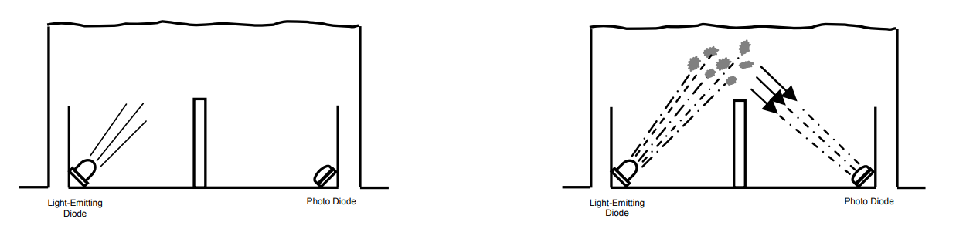

Figure 2: backscatter principe [21]

Photoelectric smoke detectors have an advantage of being more sensitive to smoke from smoldering fires compared to ionization smoke detectors which are more sensitive to smoke from flaming fires [20]. Typically, these detectors cover a protection area for around 120m2, which means a circular area with a diameter of 12 meters or radius of 6 meters [22]. When other or smaller protection areas are covered these numbers are given in corresponding manufacturers datasheets. In Austria for example, required protection areas which must be covered securely by these detectors are prescribed in TRVB 123 [23]. Also, commercial distributed detectors can only operate properly until a certain height is reached, due to slow propagation velocity of smoke mentioned in Section 2.1.1. Fire tests for various manufacturers have shown, it is safe to mount these detectors up to 9 meters to alert correctly in the case of fire [23].

These types of smoke detectors are primarily used for commercial in Europe, e.g. public buildings like schools, universities, occupancy accommodations, hospitals, office buildings etc. They are also available for residential use from different manufactures.

### Heat detectors

These types of detectors provide an alternative when ionization or photoelectric smoke detectors are improper to use, e.g. in kitchens, garages, etc. There are two principles to detect heat or temperature. The fixed temperature principle or the rate of rise principle shown in Figure 3. A fixed temperature heat detector uses an eutectic alloy as a heat sensitive element [24]. It changes its state from solid to liquid at a certain temperature, which triggers an alarm state. A rate of rise heat detector uses a thermistor specifically a *negative temperature coefficient* resistor (NTC). When temperature rises slowly this is ignored but if the value from NTC drops rapidly, due to fire being present, an alarm state is triggered.

Heat is conducted slower in air than in solid objects or gases according to Fourier’s Law [25] and airs temperature gradient [26]. This must be considered whether a fixed temperature or rate of rise heat detector should be mounted in its designated installation site. These detectors cover a smaller protection area than photoelectric smoke detectors, their usual protection area is around 28m2 which means a circular area with a diameter of 6 meters or radius of 3 meters [23].

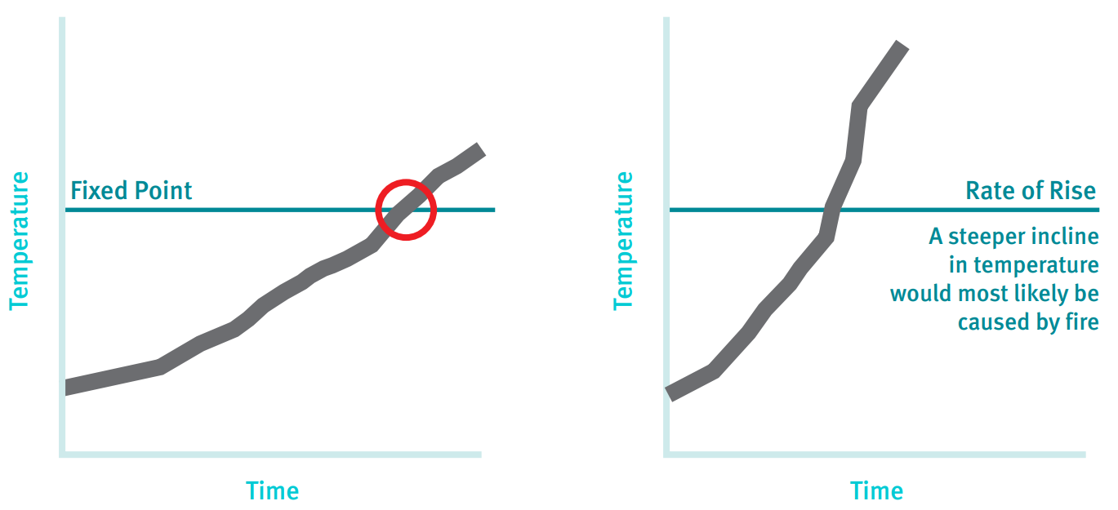

Figure 3: heat detector principles [20]

### Carbon Monoxide detectors

Carbon Monoxide is the most responsible gas [27] for victims, who die from fires worldwide, as previously mentioned in chapter 1. CO is emitted during combustion processes and is achromatic and odorless, which represents a threat for people. CO binds hemoglobin in our blood and blocks oxygen transport, which ultimately leads to inner suffocation.

The most reliable method to detect CO is a biomimetic sensor [28]. These sensors mimic biological mechanisms that take place in our body. Such a biomimetic sensor in a CO detector reproduces the same effect CO has on hemoglobin. Inside of this electrochemical sensor is a gel, which changes color as it absorbs CO from surroundings. Another sensor detects this color change to trigger into an alarm state. The biomimetic sensor is designed to change its color at 400 ppm of CO. Researches have shown that accumulated concentrations exceeding 400ppm in a few minutes are life threatening [27] [29]. If a detector detects such a high concentration or even slower ppm values at a slower rate of rise in the air, an alarm is triggered.

As of today, CO detectors should not replace conventional smoke detectors [21], mentioned in Section 2.1.2 and 2.1.3. However, in the USA it is mandatory to install CO detectors in every home [30]. In Europe they are distributed for special purposes (mostly commercial use) or in combination with photoelectric detectors only [27]. Another thing to be considered is the sensors limited service life up to10 years [31].

### Multiple sensor detectors

These detectors combine detection methods previously mentioned in Section 2.1.3 to 2.1.5 to enhance detection rate and to reduce false alarms, by combining different methods. For commercial use it is common practice that detectors offer a combination of smoke and heat detection and their response characteristic is set via software tools upon their initial activation. This allows for more flexibility and an economic approach in manufacturing, since only one detector type needs to be produced and be configured and used individually.

In Austria however, it is mandatory to use only one response characteristic due to missing fire tests from manufactures that prove an enhanced detection rate when more than one response characteristic is evaluated [23]. Normally, these detectors are interconnected to fire alarm systems. Around 4000 detectors distributed on 16 loops could be linked up onto said systems [32]. This is achieved by using a bus system Modbus [32] which resembles the *European Installation Bus* (EIB) / KNX standard. Also, different operating voltage levels, e.g. from 7 V to 31 V [33] increase the number of detectors on one loop up to 256 elements. These fire alarm systems also work with various protocols like *Building Automation and Control Networks* (BACnet), *Open Platform Communications* (OPC) and provide a wide range of actions when smoke or fire is detected [32] [34].

More recently, companies also offer detectors for commercial use which can detect smoke, heat (both fixed and rate of rise temperature) and CO as well [35]. There are also companies who distribute multiple sensor detectors for private households, which can detect smoke and CO [36] or smoke and heat [37] and offer integration into existing smart home networks. This gives customers more security and reliability but also higher costs per detector. These combined detectors are typically state of the art, but single response characteristic detectors are usually more affordable and offer easier maintenance for consumers.

### Aspirating smoke detector systems

*Aspirating smoke detector systems* (ASD) work differently than regular smoke detectors although they most use the same backscatter principle as described in Section 2.1.2. In fact, they are usually comprised of one or two highly sensitive photoelectric smoke detectors  
(Figure 4).

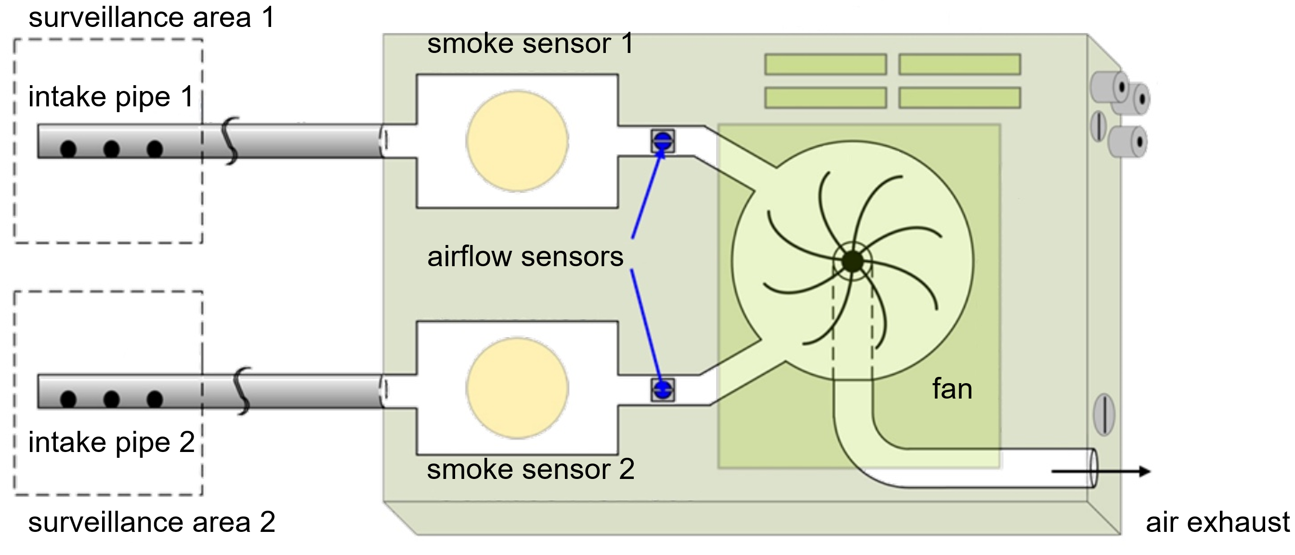

Figure 4: structure of aspirating smoke detector systems [38]

These systems aspirate air through one or two separate pipes (installed within the surveillance area) with aspiration holes at fixed distances. This is accomplished with a small fan inside the system. This stream of airflow is filtered first with filters mounted externally. This filtered airflow permeates the smoke detectors inside. If a predetermined alarm sensitivity is exceeded, an alarm signal is triggered from the system. These detectors are often equipped with autolearning functions to accommodate and adjust constantly to their surroundings.

ASDs are used where conventional smoke detectors cannot operate reliably. This occurs e.g. where these detectors could not work reliably (too hot, too cold) or in areas where room height exceeds 9 meters like in high rise storage rooms, theatres, airports etc. They are also installed in clean and sterile rooms, server rooms and data centers. Also, one ASD could cover a much larger protection area than a single detector with up to 5760m2 [38]. Additionally, these systems can detect fire at much faster rates as depicted in Figure 5. They already sense particles when fire ignites, and pyrolysis just started.

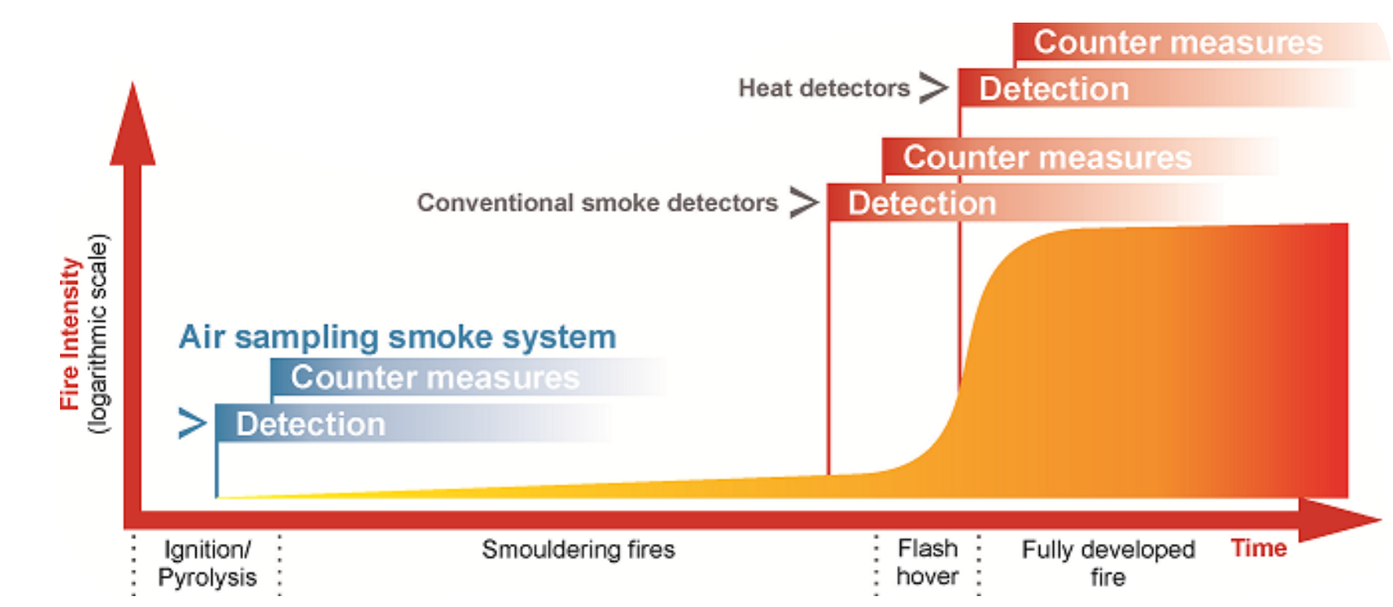

Figure 5: comparison of smoke detection rates [39]

For an even higher reliability and faster response rates *Very Early Smoke Detection Apparatuses* (VESDA) were developed around the 1970s in Australia. These operate with the nephelometer light scattering principle, which allows to detect even the smallest smoke concentrations [40]. Inside of this system is a tube with a light source, one inlet and outlet for air samples. For detection there are xenon or laser diodes with photo-diode receivers. These photo receivers measure the wavelengths of scattered light (red 700nm, green 550nm and blue (450nm) [41]. They are calibrated to detect a deviation of these wave lengths when aerosol or smoke particles are present.

It should be noted that basically every ASD is used for commercial purposes only and is not sold to personal households, due to their intended purpose, high selling price and costly installation.

### Linear detectors

These detectors work with an obscuration principle [20]. An IR light beam is emitted from a transmitter and this light beam is received from a receiver on the other side of the protection area. When smoke particles or aerosols are in the air the receiver detects a reduction of signal strength and an alarm condition is met. There are two ways linear detectors are used. Either with a separate transmitter and receiver or with dual transmitter/receiver and a reflector, as depicted in Figure 6.

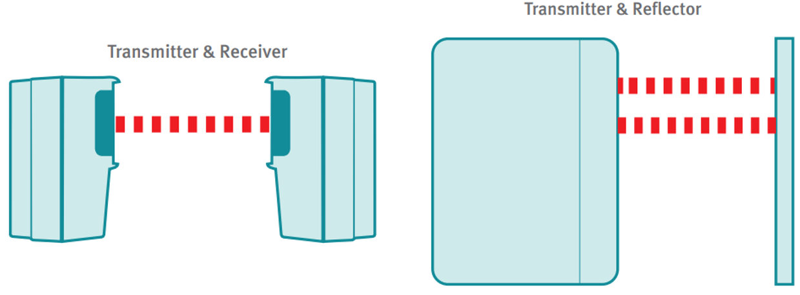

Figure 6: linear detectors [20]

Usually linear detectors are installed in exposed heights and unwanted obstructions e.g. flying birds, workers on hydraulic lifts need to be suppressed. Integrated algorithms can determine if fire or an unwanted obscuration took place. Furthermore, auto-realign functions ensure that transmitter and receiver are and stay in line of sight.

These detectors are used in large open areas, atriums, areas with monument protection (where conventional smoke detectors cannot be installed) or in areas where height exceeds 9 meters. They can be installed at a height up to 40 meters and their range can be up to 100 meters [20].

### Wireless smoke detectors

They utilize the same backscatter principle as photoelectric smoke detectors. Although each detector works independently of any wired connections and is battery powered. Usually they are connected in mesh networks to dedicated gateways (which are interconnected to a fire alarm system themselves). A certain range and as less obstruction as possible are criteria which need to be met. These networks operate with two separate *short-range device wave bands* (SRD), either with 870 Mhz or 435 Mhz. In the case of an error, a channel switch on the main band is initiated first, then the wave band is changed automatically [42]. Inside these networks only a defined number of hops to transfer to a signal to the gateway are allowed to maintain standards defined in EN 54-1 [9].

This hop limitation reduces time to a minimum to transfer alarm states from an element to the gateway and allow as much as possible elements connected to one gateway. When nodes on one of the primary routes fail to transfer, there must at least exist one or more secondary routes to transfer the alarm condition as shown below in Figure 7.

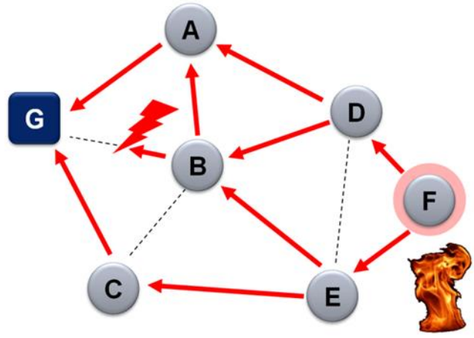

Figure 7: smoke detector mesh network [43]

Wireless smoke detectors are commercially used only in structures where building codes restrict wiring due to monument protection, e.g. historic buildings, museums.

### Smoke detectors for home use

For private usage smoke detectors are sold to customers in wireless and battery powered designs. They are meant to work standalone or in combination with others to build up mesh networks (but not connected to gateways mentioned in section 2.1.9). A wide range of detection principles are used for these detectors. There are photoelectric but also more costly designs which offer multiple sensors for smoke and heat or smoke and CO, as previously described in section 2.1.6. Depending on a customer’s budget they also provide an integration into their existing smart home network [36]. This allows for notifications to smartphones, simplified maintenance, the current status of detectors is accessible or alarm forwarding among each element in a mesh network. The latter helps, when a detector is installed in every room and fire is detected in the basement, for example. Every detector beeps to alert all rooms, shown below in Figure 8.

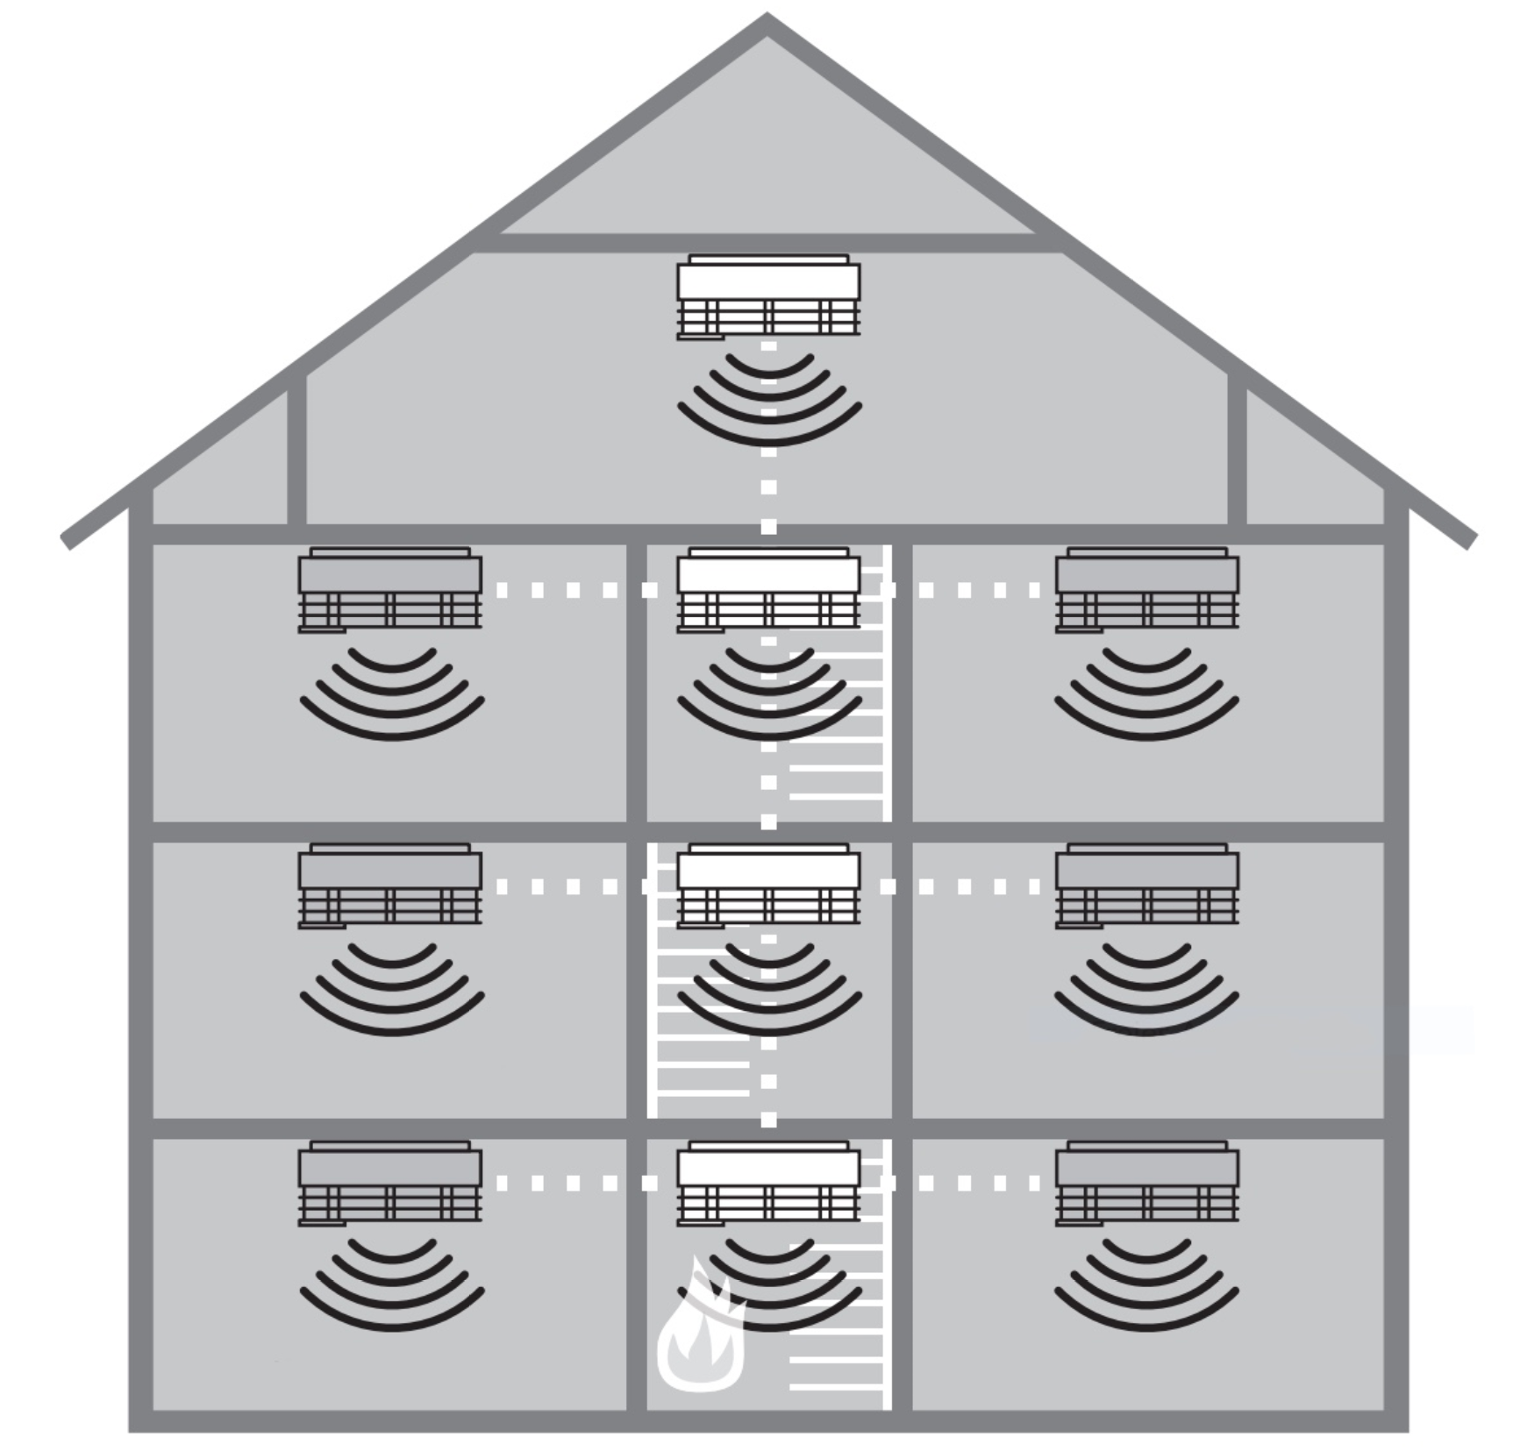

Figure 8: alarm forwarding of wireless smoke detectors [44]

# Web Development

This chapter provides an overview, which web development languages, standards, protocols and software were used, to enable interaction for each component of the prototype design.

## Hypertext Markup Language 5 (HTML5)

HTML is an acronym for Hypertext Markup Language. This is a text-based markup language for a structured depiction of texts, graphics, or links, rendered within web browsers [45]. These documents are written and not programmed, hence the name markup language. HTML Version 5 comprises HTML4.01 and XHTML1.0 (*Extensible Hypertext Markup Language*) and further features like audio, video codecs or 2D / 3D graphics. Since a html file determines a web page’s content and structure, it is assigned to the content layer.

This content may be, e.g. a web presence, static or dynamic web page or a *Rich Internet Application* (RIA). Latter use third-party supplier’s *application programming interfaces* (API) and plugins to provide better usability or performance. HTML files are usually accessed with requests from a client to webserver. Said files consist of a header within the <head></head> tags and the body within the <body></body> tags [46]. The header displays the name of the web page in the browser window. Everything written between body tags is the visible area rendered by the browser.

## Cascading Style Sheets (CSS)

These were introduced in the 1990’s by the *World Wide Web Consortium* (W3C) [45]. Version 3 (precisely added modules on top of Version 2 with more capabilities) was released around 2000 [47]. CSS files are used to define the look, colors, font sizes, i.e. the layout of a web page. Hence these files are related to the presentation layer. It is recommended (but not mandatory) to create an external CSS file and use <link ...> inside the html’s header to apply its style rules. These rules are applied with both a selector (an element is specified, e.g. h1, p or specific classes preceded by a period) and the declaration (properties like color and a matching value like blue for example) [48].

## JavaScript

Since its introduction in 1995, *JavaScript* (JS) is used to increase usability and interaction for web pages or web applications [49]. Further uses are frontend and backend development for example (client side, server side). More recently important is native mobile application development these days. Also, embedded systems and the *Internet of Things* (IoT) became application areas for JS as well. JavaScript operates on a behavioral layer, which means code written in JS determines which interaction or processing of the underlying’s web page’s element is given.

This code is either embedded within the HTML5 file itself or is accessed from an external JS file with a <script> tag. An important feature of JS is its handling of asynchronous requests from clients with the introduction of *Asynchronous JavaScript and XML* (AJAX). This enables to dynamically reload specific content of a webpage or application, e.g. a webpage’s live ticker. validating of input forms. This asynchronous approach for programming is applied various methods [50]. For example, with callback functions. An action starts, when it finishes, a callback function is called with a result. Or with a standard class named Promise. This asynchronous action resolves at some point to produce a value. Upon completion a promise can notify, that this value is available. Asynchronous actions or computations can fail, hence a convention to throw exceptions on failures is used. These are either rejected by promises or caught with a method catch. To ensure no error-prone features are employed or executed, it is advised to use JS’s strict mode with 'use strict' in the first line of a JS file.

## Node.js

Node.js was introduced around 2009 [49]. Since JavaScript acts as an asynchronous event-driven runtime, many connections or events need to be handled concurrently [51]. Node.js fulfills these requirements, i.e. no blocking I/O calls. This contrasts to threads in operating systems, which are employed upon execution. Node.js represents as a single-thread event loop, hidden from the user, to support concurrent connections with suffering thread context switching.

## Hypertext Transfer Protocol (HTTP)

Around 1995 the HTTP/1 protocol was introduced. It allowed chunked transfer encoding for response streaming, request pipelining for parallel processing and better catching mechanisms for example [52]. With HTTP/2 request and response multiplexing were introduced. It lets a HTTP messages separate into independent frames, which are transmitted interleaved and reassembled at their destination. *Server-Sent Events* (SSE) also facilitated more efficient server to client streaming, e.g. real time notifications or updates on a server, via *Document Object Model* (DOM) events within an EventSource interface.

## Transmission Control Protocol (TCP)

All TCP connections start with a three-way handshake between a client and server. The client must send a random sequence number and sends the packet with additional flags to a server. The server acknowledges (increases the acknowledge number) and responds the package. The client now completes the handshake (both sequence and acknowledge number are increased) and dispatches the received packet [53]. This ensures a reliable and secure transfer of information from one source to its destination.

# Design Specifications

All given functions of a chosen smoke detector shall be implemented adequately into a design to a specific extent. These requirements are described in the subsequent sections. Functional requirements determine all necessary functions and the behavior the design is supposed to accomplish. All given resources or capabilities of each component should be used appropriately. Also, there are no additional functionalities designated for the realized system. Nonfunctional requirements describe the system quality and determine how well it is realized and implemented.

## Functional Requirements

1. Access to the smoke detector signals and functions shall be given via a webpage or appropriate framework
2. Transmission of a smoke detectors fire/smoke alarm signal to a user’s web browser e.g. onto a smartphone or tablet with an interconnection over the Tessel 2 microcontroller
3. Various states i.e. idle, alarm state shall be visible at any given time, assumed a present connection is established
4. When a status change occurs, the user shall not need to manually refresh the webpage or framework
5. When no steady idle signal is coming from the smoke detector or connection to the Tessel 2 is lost, regardless for whatever reason, a notification should inform the user that a malfunction occurred

## Nonfunctional Requirements

1. The states for idle and alarm shall be visualized with colored elements for easier readability

# Prototype Design

The following sections describe which components are used and how they work together to fulfill the defined functional and nonfunctional requirements, described in chapter 4.

## Concept

The system is divided into three components. A hardware part, which is responsible for smoke detection and providing all relevant information and signals needed. The second part is a hardware/software component responsible for processing and transferring these information and signals. The third component is the user’s device displaying the interface. The structure of this system is depicted in Figure 9 to illustrate how these components, hardware, software and user device are linked.

## Architecture

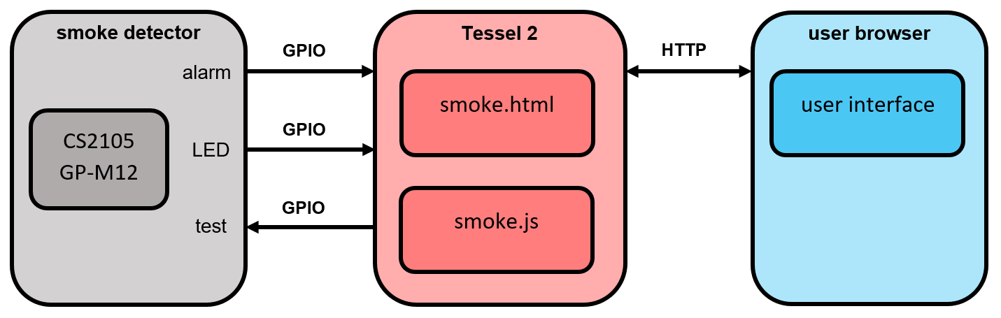

Figure 9: block diagram of prototype design

The hardware part comprises a photoelectric smoke detector. It is linked to the Tessel 2 via three separate connections. Two inputs, one for smoke detection and one for its flash LED to indicate the smoke detector is in operation. There is also one output to use the smoke detectors built-in test function. All inputs and output need further processing and are handled and evaluated from the T2. The T2 establishes a network connection, runs a JavaScript file to host a webserver and handle requests with the accompanied HTML webpage (see FR1 in 4.1). A user may now access this webpage, to see current states (i.e. is there an alarm or to check if the smoke detector runs properly) or may use the test function (see FR2 in 4.1).

## Hardware

The hardware, which was used, to realize this prototype was an affordable smoke detector from “Obi” at a price of around €10 and the predetermined Tessel 2 microcontroller.

### Smoke detector

This smoke detector comes with an CS2105 GP-M12 *Integrated Circuit* (IC) on its *printed circuit board* (PCB) from manufacturer Semic, which is pin compatible to a better documented MC145012 IC [54].

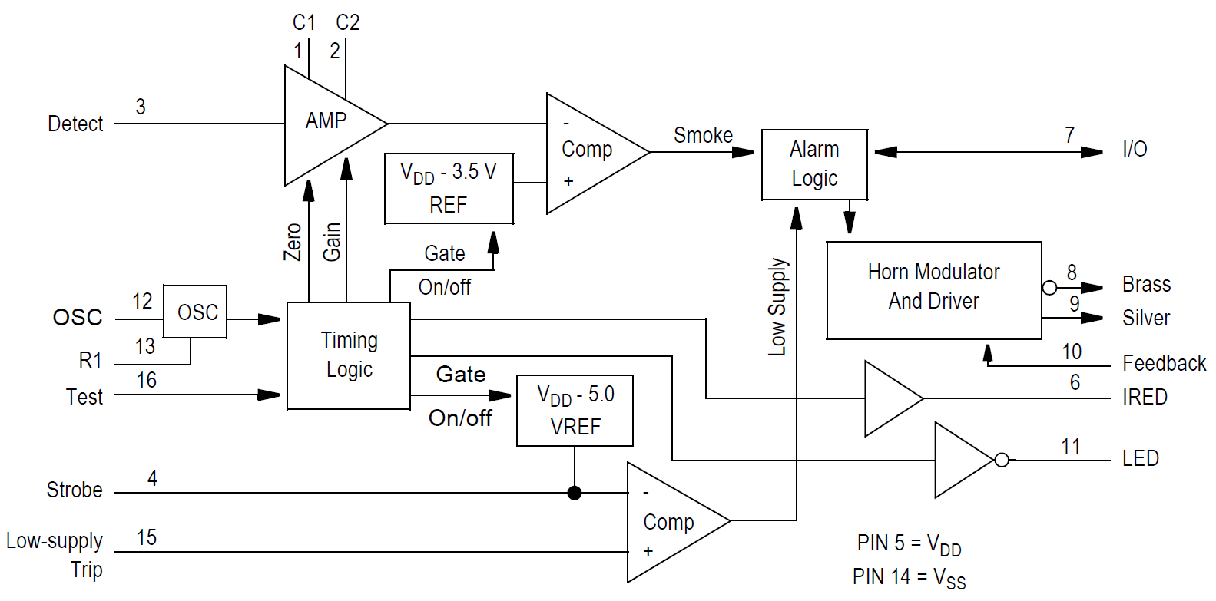

Figure 10: block diagram of CS2105 GP-M12 [54]

This chip offers necessary outputs and inputs needed to realize a functional prototype. It provides an alarm input/output on pin 7, acoustic feedback on pin 10, a flash LED on 11 and test function on pin 16 depicted in Figure 10 and Table 1. The complete pin specification is also depicted below. This detector runs on an integrated 9V-battery.

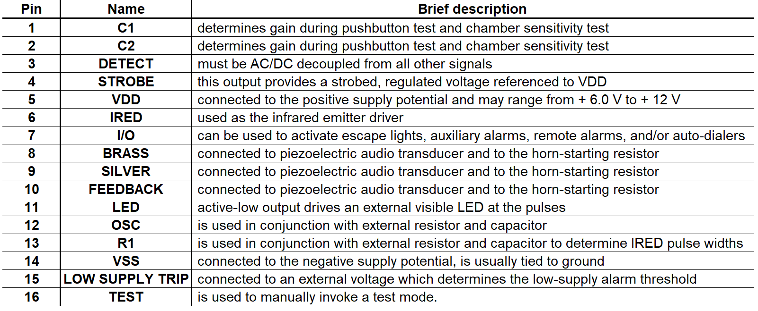

Table 1: pin specification of CS2105-GP-M12 [54]

### Tessel 2

This board is based on a *Wireless Fidelity* (WiFi) router *System on Chip* (SOC) Mediatek MT7620n running Linux via *OPEN Wireless Router* (OpenWRT) [55]. It also comes with an Atmel SAMD21 microcontroller [56]. Both build a processor/coprocessor architecture. The Mediatek runs user specific code, handles network connectivity via *local* and *wireless area network* (LAN)(WLAN) and *universal serial bus* (USB) and communicates with the microcontroller. The coprocessor handles low level Inputs and Outputs through two *general purpose input and output* (GPIO) banks which various modules could be attached for application specific inputs and outputs.

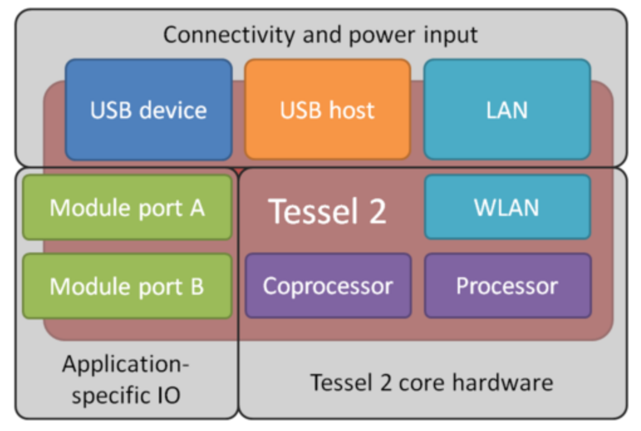

Figure 11: functional blocks of Tessel 2 [57]

Below is the pin mapping of the T2 GPIO Banks, interesting for this prototype implementation are PINs capable of detecting interrupts, e.g. on GPIO Bank A PIN 2, 5, 6 or 7.



Table 2: pin mapping Tessel 2 [58]

## Software

The following flowchart in Figure 12 describes the execution of the prototype design on the T2, which is implemented in two separate files, a HTML file with included CSS styles and a corresponding JS file.

At first, the webserver is started to run the application. This gives the user/client access and also sets up functions needed for interaction between the smoke detector and the T2. Within the embedded JS file, the static HTML file is accessed. When there is no request coming from the user the index.html shall be displayed. The user interface consists of two basic elements. One division which is toggled from green to red, in case of an alarm and a test button trigger the test function remotely underneath the division.

If the user accesses this webpage over the localhost within a web browser the HTML’s interface is presented. The user may now use the test button to trigger the smoke detectors test function. If so, a request to for a test function is called from the server within the JS file. This function toggles the state of test pin and subsequentially triggers the smoke detector’s alarm / test function. When an alarm occurs a function to determine the alarm state is called. This changes the class id of the division to turn from green to red (see NFR1 in 4.2).The styles which are applied are located within the HTML’s header. The current state of the detector, green when everything is ok and red if smoke was detected (see FR3 in 4.1). Also, a green and a red LED on the T2 should indicate the user which states are currently present, without to manually refresh the webpage (see FR4 in 4.1)

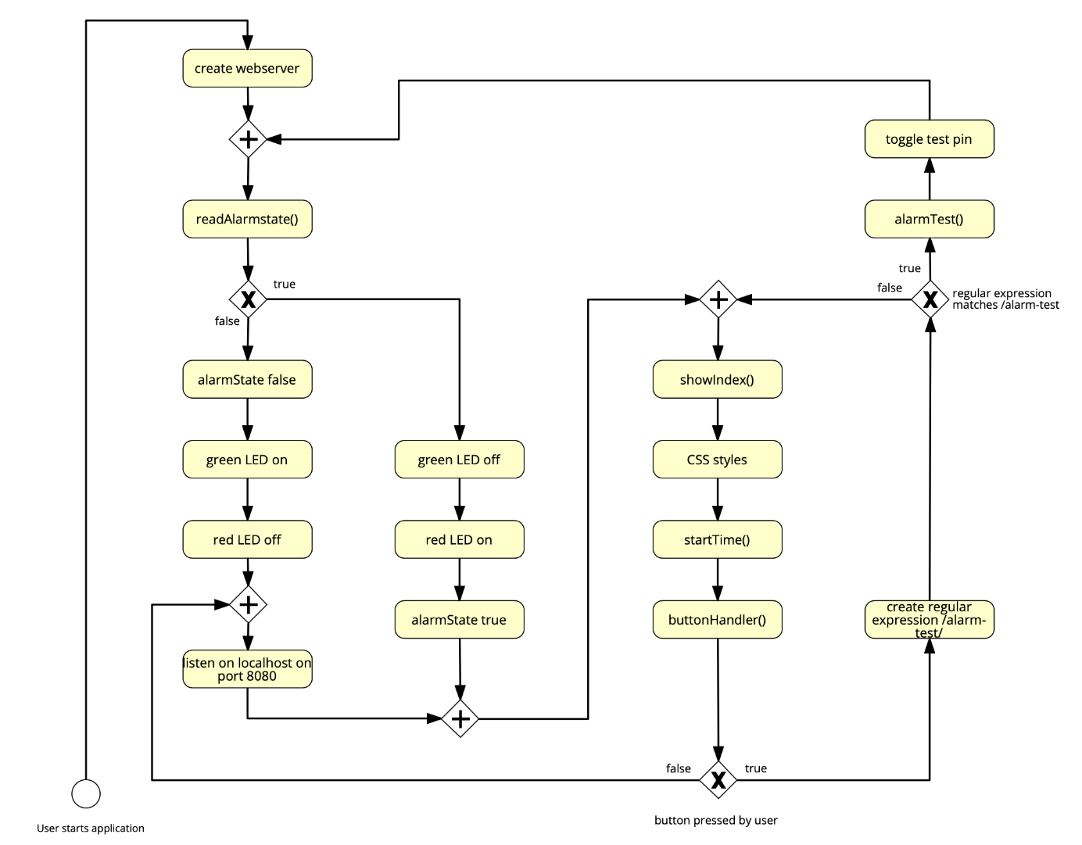

Figure 12: prototype flowchart

# Technical Implementation

This chapter describes necessary steps to realize a prototype based on the design specifications.

## Initial Setup for Tessel 2

Before setting up and configuring the T2 microcontroller, Node.js is needed. A Node.js version greater than 4.2.x is recommended for download. With this installation, the tool *node package manager* installer (NPM) is also installed. This gives access to download packages within the command line, i.e. using the NPM installer. The Tessel 2 is configurated and controlled using the command line. To setup the T2 all following commands mentioned in this section are entered in order of appearance, below in Listing 1 within the command line [58]. The T2 command line interface and t2 are downloaded with the NPM installer. The command line interface needed to process commands and to communicate with the microcontroller. Since the command line interface checks on startup, if the latest version is used, no further updates are required. However, t2 is versioned separately and it is recommended to update with shown update commands. The command t2 version displays with version is currently running on the Tessel.

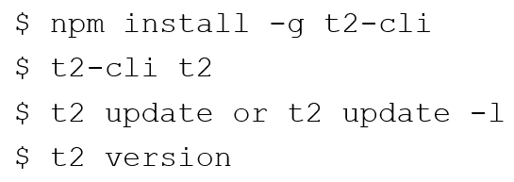

Listing 1: initial setup of Tessel 2

Next step is setting up a USB connection, which does not require any specific setup. How to configure and run or erase code are shown, in order below, in Listing 2. After the Tessel 2 has successfully booted (indicated with a steady blue LED instead of a blinking one). To check, if the Tessel is successfully connected to a computer the list command is typed in. When a T2 is detected, it shows up with its serial number. Then, the microcontroller is renamed with the command to bachelor, although this is not necessary or required to deploy code to the T2. Since the Tessel 2 is based on a router SOC, it allows for a convenient connection to a computer over WiFi. This is connection is enabled, when the computer is connected to a WLAN. With the wifi command this connection method is enabled. When the T2 is connected over WiFi an amber LED flashes to indicate that packages are sent and received successfully. Lastly, a check with list command displays the Tessel 2 is now connected over USB and WiFi as well.

Then, a secure and trusted connection between the computer and T2 a provision must be made in order to deploy code over *Secure Shell* (SSH). To authorize the device, it must be provisioned first. To start a project, the initialization command creates a folder with all files needed for startup, i.e. a package.json and a index.js file to start from. Code may now be edited in the generated JavaScript file and copied into the microcontroller’s flash memory with the run and push commands. There is an advantage of using pushing instead of the running command. The T2 will automatically run this application, every time it restarts. The run command only runs code until the Tessel 2 is restarted or turned off. To erase code and dependencies from the *Random Access Memory* (RAM) the command t2 erase is used.

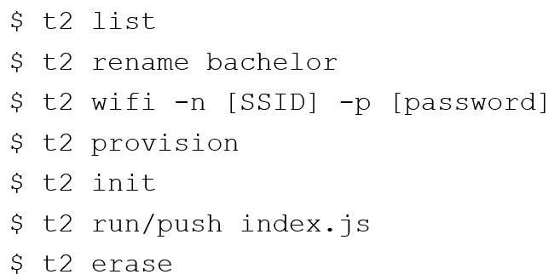

Listing 2: configuration and runnig code on Tessel 2

## Input and Output Processing

The T2’s digital I/O ports are only eligible to detect 3.3V, since its GPIO’s operate on 3.3V internally. Hence, for input and output control, an external wiring between the smoke detector and the T2 is required. Three GPIO pins, according to the pin mapping, in Table 2 are used. These pins are eligible to digital states and to detect interrupts, i.e. rising or falling edges with 3.3V voltage levels. PIN A2 is used to detect the smoke alarm. PIN A5 covers the flash LED signal and PIN A7 is used as output to trigger the smoke detectors test function. PINs A1 (GND) and A2 (VCC) are used as well, since these are needed to apply correct voltage levels for creating rising or falling edges.

As mentioned before, Tessel 2’s PINs A2, A5 and A7 may not be connected to the smoke detectors IC directly. An external wiring between detector and microcontroller isolates both circuits from each other. Hence, this prevents high currents flowing inside the T2’s GPIO PINs. This also reduces voltage levels provided from the smoke detectors CS2105GP-M12 IC  
(~4V to ~9.8V) to appropriate voltage levels, which the microcontroller can process. This is achieved with three opto-couplers, two for input signals and one for output. The wiring is depicted below in Figure 13.

PIN 7 and 11 (smoke alarm, flash LED) from the smoke detectors IC are connected to the two respective opto-coupler anodes to drive the IR-LEDs inside the opto-couplers. PIN 14 (VSS) is connected to the two respective opto-couplers cathodes. The positive supply potential of the battery (Batt) is connected to the third opto-coupler’s source pin with a pull-up resistor. Pin 16 (test function) is wired to the third opto-coupler.

The GPIO PINs from the T2 are wired as follows. PIN GND is connected to opto-coupler’s 1 and 2 emitter pin via pull down resistors and to the opto-coupler’s 3 cathode pin. PIN 3V3 is wired to the source pins of opto-coupler 1 and 2, to provide 3.3-voltage levels. PIN A2 and PIN A5 are connected to the first and second opto-coupler’s emitter pin directly. PIN A7 is wired to opto-coupler’s 3 anode pin to drive its IR-LED. If there is a ‘high’ signal on PIN 7, opto-coupler 1 is turned on. This creates a high level on T2’s PIN A2. Every time PIN 11 is ‘low’ (the flash LED is low active every 43s [54]), this creates a high level on PIN A5. To initiate the test function, a positive supply potential needs to be applied to Pin 16. To achieve this, PIN A7 needs to be turned ‘high’ and applies 3.3V to turn opto-coupler 3 on.

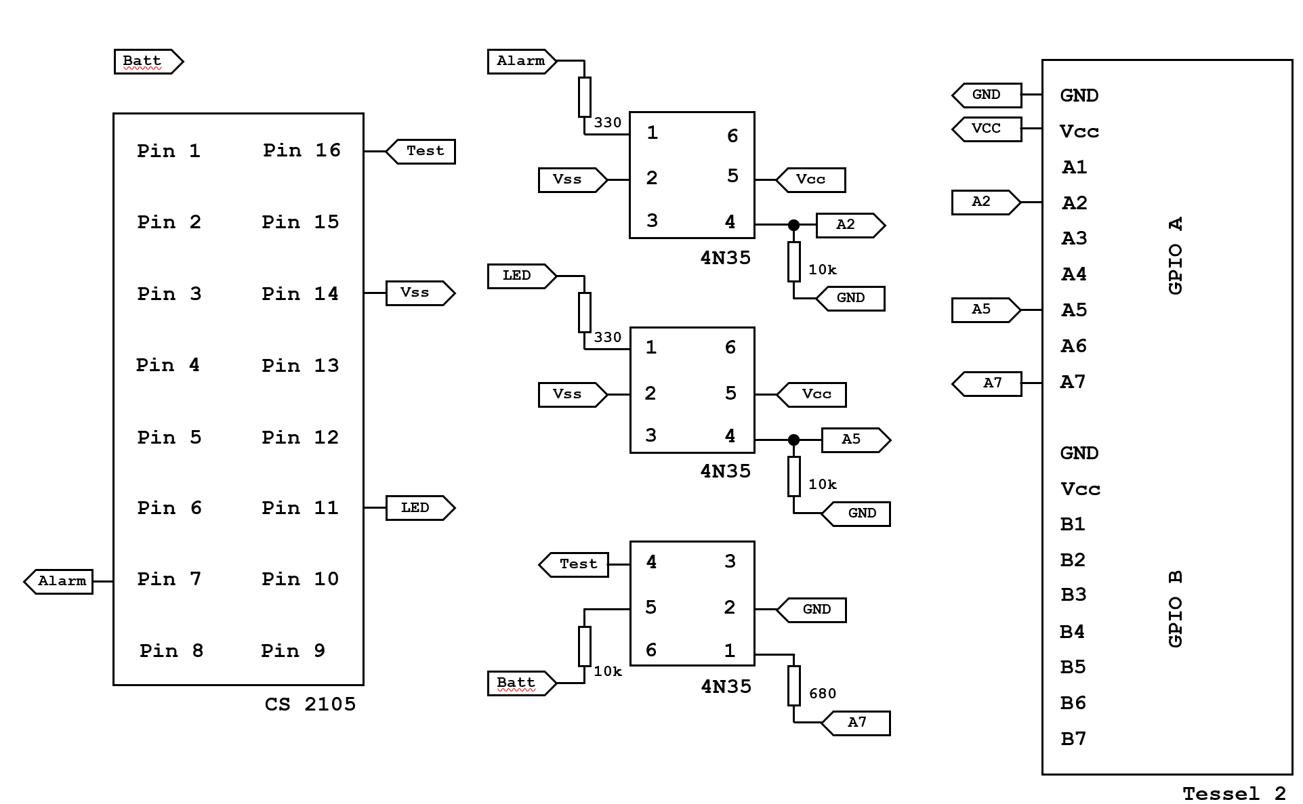

Figure 13: external wiring between detector and microcontroller

## Smoke Alarm and Flash LED

At first, it was intended to detect a rising or falling edge on PIN A2 coming from opto-coupler 1. But this method to detect edges eventually became unreliable. Therefore, the digital state of the pin is polled and read every 100 ms. The code snippet depicted in Listing 3 shows how to read digital states. In order to detect a clean low level, the pin was configured with an internal pulldown resistor. Otherwise there was no clean 0.0V on PIN A2, due to being connected to opto-coupler 1 (~0.6V before). Additionally, a previously declared variable ledRed turns the T2’s red LED on in case of an alarm and alarmState, initialized with false, is set to true. The smoke detector eventually goes to idle again. If this happens, i.e. no alarm and low is detected on PIN A2, this toggles the red LED off and sets the alarmState to false again.

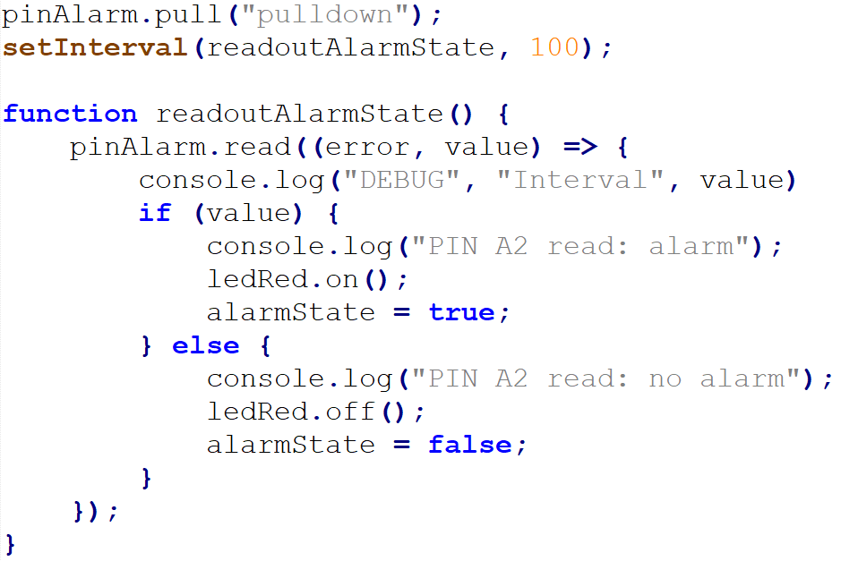

Listing 3: smoke alarm detection

This alarm state is responded inside a function which creates a response and displays the index.html read from the file system. Inside the HTML’s division is a placeholder $$alarm$$ which is replaced after string conversion, with either a “class=‘alarm‘“ or with ““ using a ternary operator, in the code snippet in Listing 4. In the case of alarm, the divison is changed to red. When there is no alarm the division remains green.



Listing 4: placeholder for division

After setting up all external wiring between the microcontroller and the smoke detector, it was found out through testing, that the signals for alarm and flash LED are shorted. This is because both inputs are connected to the VSS Pin on the detector (see Figure 13). Since the flash LED is low active and the alarm pin is low when the detector is idle this shortage occurs. Therefore he flash LED function was not integrated into the final design, because the chosen hardware will not allow to retrieve both signals at the same time. This means that FR3 is only partly fulfilled, since only the alarm state is displayed, which is nevertheless more important for the application itself.

## Test Function

Also included in the smoke.js file is a function to toggle the state of the test pin on PIN A7, called alarmTest(). This function is illustrated in Listing 6. It also includes a separate function to toggle the green LED on the T2. When the button is clicked the function buttonHandler() is called, shown in Listing 5. This event for the button creates a request to the server with the regular expression /alarm-test/.

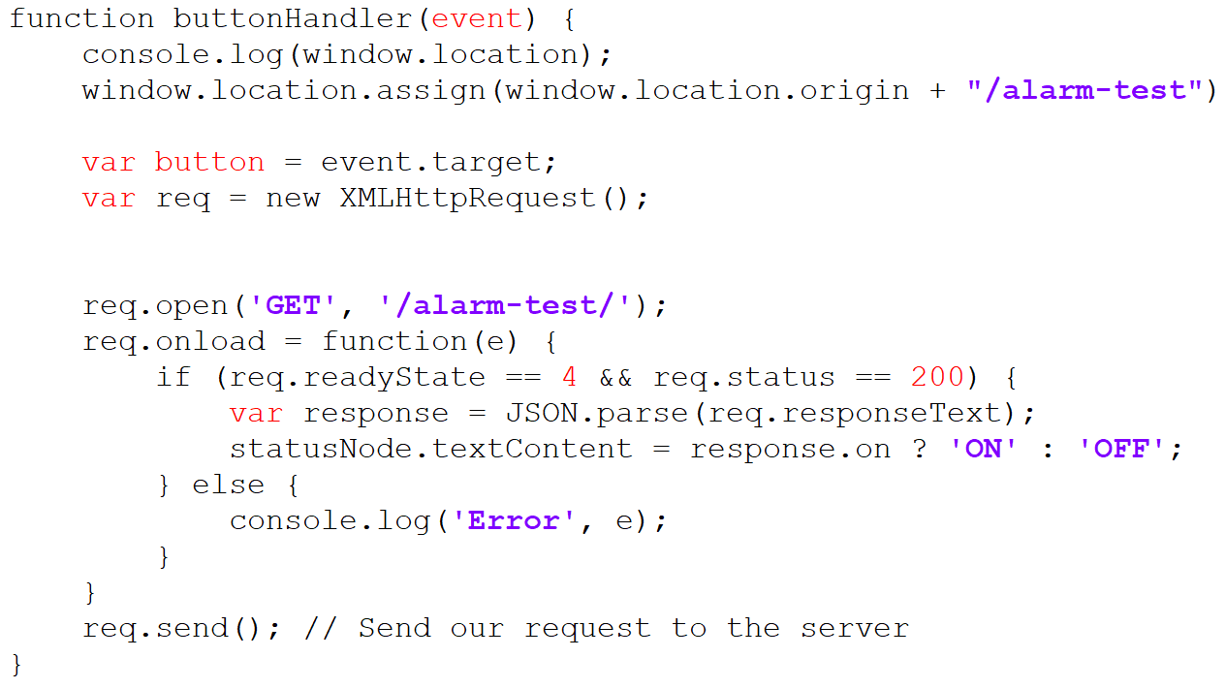

Listing 5: buttonHandler function

This click event created request is send to the server. The server now responds to this regular expression with the previously mentioned alarmTest() function. When this function is called, the value of PIN A7 is toggled with the method pin.toggle() and applies 3.3V or 0V to the pin respectively. In a separate function led.toggle() the green LED is toggled off or on. After the green LED is toggled, the server shall also respond with the content from the static index.html to redirect the user to the interface. In case the pin could not be successfully toggled, an error is thrown.

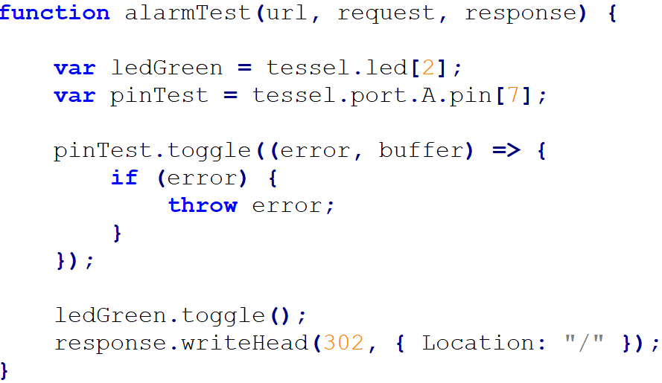

Listing 6: alarmTest function

When the test button has not been clicked yet, the green LED is turned on in and the red LED is off. This indicates the user that the smoke detector is ready and idle. If the test button is by the user clicked, the green LED turns off, to show a test was initiated and received from the T2. In succession the red LED turns on, because the alarm state changes.

## Client Application

The static HTML file accessed by the webserver consists of two basic HTML elements as already mentioned in 5.4 – a division and a button. The CSS styles, which are applied reside inside the header of the HTML file and are shown in Listing 7. The body of the webpage is set to flex, this allows for an easier layout without using float or positioning. The division’s background color is set to green when the detector is idle and there is a class .alarm which is set to red when alarmState is true, shown in Listing 3.

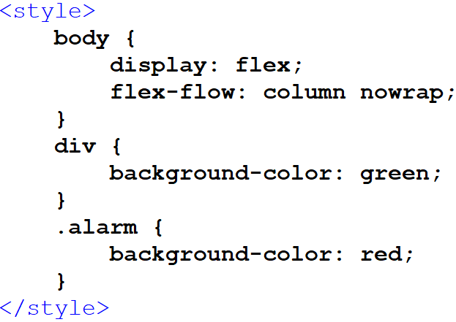

Listing 7: CSS styles

Below in Listing 8 is the body of the webpage. Inside the body are the div and the button. The button’s onclick event calls buttonHandler(), which is depicted in Listing 5.

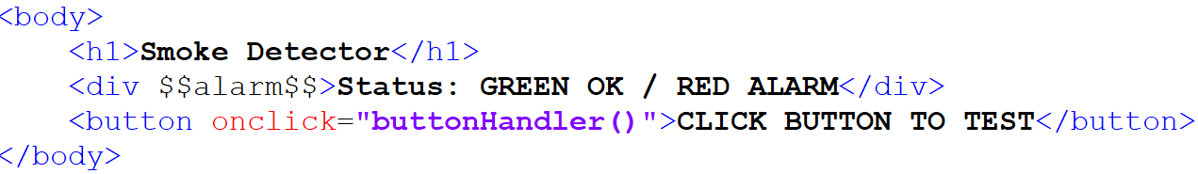

Listing 8: HTML body

## Webserver Configuration

The now created JavaScript and accompanying HTML file are pushed into the T2’s RAM. One dependence is essential. It is the 'tessel' module. This establishes a library to interface with the Tessel 2. To access the http module, it is also included with require('http'). Two further core modules from Node.js are also required. Firstly, the core module 'fs', which stands for file system. This allows to gain access on files within the file system of a computer. Secondly the module 'url', which splits up a web address into readable parts. Both core modules are also included again with the require() method.

The webserver configuration is shown in Listing 9. To create a server object the method http.createServer() is called. First, the web address is partitioned with url.parse() into parts. Then, a regular expression is instanced. This regular expression is used to search for a matching string, in this case for /alarm-test/ which is a XMLHttpRequest from buttonHandler() [50]. If there is a match, the function alarmTest() is responded from the server. In all other cases the server returns with showIndex(), a response header with status code 200 and the index.html with the respond.end() function containing the placeholder depicted in Listing 4. The created webserver listens to port 8080 and a user may access the webpage on <http://bachelor.local:8080>. To indicate that the webserver is up and running a message is displayed in the console window and the green LED is turned on additionally.

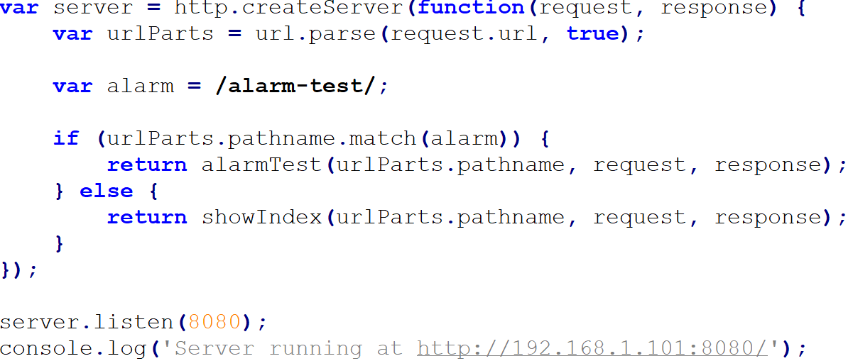

Listing 9: webserver configuration

## Prototype

Picture, description

# Results and Discussion

In this chapter results which have been found during this work are described. Based on these results, conclusions are drawn in terms of security and reliability or related to current market trends. Additionally, after reaching these conclusions there is still room left for improvements, which are also described at the end of this chapter.

## Results

The goal to create a functional prototype based upon a cost-efficient smoke detector in combination with the predefined Tessel 2 microcontroller is accomplished in this Bachelor Thesis. This realization gives a user access to the smoke detectors current status or to trigger the smoke detectors test function remotely over a dedicated web presence. Insights about fire safety and current state of the art principles how to detect smoke or fire are also explained in the first half of this thesis.

## Reliability & Security

During this work, several test cases[1] have shown that a “cheap” home smoke detector’s reliability to detected smoke properly is given at any time. Yet, the achieved implementation lacks security features. For instance, when the smoke detector is disconnected from the T2 for any reason, the internal battery voltage falls under its supply threshold, or the T2 may not connected to the WLAN or is powered off for whatever reason. There is also no security feature built in, which protects the T2 from accessing from an outside source within the WLAN. Code may pushed through the provisioned computer to the T2 but there is still a way for e.g. man in the middle attacks. Since the realized implementation does not alter the detectors functionality nor changes to the used hardware were made itself, the detector’s EN 14604 certification is still applicable.

## Costs & Market Situation

One advantage of the developed prototype during this work lies in its possible affordability. There are several other solutions on the market available. Most notable is the “Google Nest Smoke Detector” [36]. This detector offers smoke and CO detection and smart home integration. This integration into an existing smart home environment is granted without further additional hardware. Setup and configuration are executed on a user’s smartphone.

Alarm notifications, low battery notifications, built in test and maintenance functions or family sharing of alarms and notifications are its core features. Unlike most smoke detectors available, this detector has a split-spectrum smoke sensor [59]. This sensor allows to detect both smoldering fires and flaming fires earlier compared to photoelectric detectors (see 2.1.2) and a 10-year electrochemical carbon monoxide sensor. The “Google Nest Smoke Detector” is the most expensive detector on the market, although this price is justified, in my opinion.

There are also two more budget friendly options to upgrade or retrofit already installed smoke detectors in an existing household. Either with so called listeners [60] or with smart batteries [61]. Former are connected to a WLAN. They do not detect smoke itself. They constantly listen for sound of a detector’s beeper or siren to send a notification. Latter replace existing 9V batteries inside the detectors. They have built-in WiFi chips and antennas to establish a connection to home networks. These batteries also detect the sound of a smoke detector and notify in the case of alarm or when its low supply threshold is reached.

## Future Advancements & Outlook

The focus on this work was to establish and develop a functional prototype, but there are several other points, which could be further improved or enhanced. As mentioned in section 7.2 the prototype does not contain any safety measures or mechanisms for data or hardware protection. Besides mandatory WLAN encryption and the *WiFi Protection Access* (WPA2) standard the implemented system is vulnerable. This vulnerability may reduce with inclusion of *Transport Layer Security* (TLS), which could be added in future iterations.

Users are not constantly present at home, to monitor or check the current status of either the smoke detector or T2. Therefore, a possibility for an automatic notification should be given. These could either notify when there is an alarm or when the smoke detector or T2 are disconnected for whatever reason. This feature might be implemented with a Firebase Cloud Messaging service or application [62], to send notifications to remote devices outside the WLAN, via E-Mail for example.

Since smoke detectors are mounted on a ceiling, an external wiring to the T2 may not the best option for an interconnection. There is one possible solution with an addition of a low-power WiFi chip, like the ESP32-SOLO1 [63] inside the detector housing itself. This chip offers well enough GPIO Pins and a WiFi antenna (or Bluetooth). Also, it is very energy efficient with around 5 μA sleep current, which makes it suitable for battery powered devices like a smoke detector.

The developed web presence is currently not optimized for any other remote devices like smartphones or tablets in terms of visuals, design, scaling or responsiveness. A user interface optimized for mobile devices makes sense, since we use them regularly at home or on the go and it is more convenient. In future versions these optimizations could be included to improve its usability.

# Summary

This thesis has two purposes. It explains thoroughly current state of the art principles to detect smoke or fire for a selected variety of detector types using various available references and literature. Also, as part of this thesis a functional prototype with an interconnection between the Tessel 2 microcontroller and a smoke detector was realized successfully. Most of the defined functional requirements and a nonfunctional requirement for this prototype are either fulfilled completely or partly. FR1 is fulfilled since the user can retrieve the current state of the smoke detector over a hosted webpage on the Tessel 2. FR2 is also accomplished, since the smoke alarm signal coming from the detector is transmitted to a user’s terminal device, e.g. smartphone, tablet. FR3 is partly fulfilled since the status of the flash LED could not be received concurrently with the current alarm state on the microcontroller. This is caused by a hardware related issue, because the alarm pin is high active and the flash LED is driven low active, which resulted in shortage. This issue could not be resolved with a different external wiring or with a different smoke detector bought, since it also featured the same IC on its board. FR4 and FR5 are not accomplished since the focus shifted to achieve FR1, FR2 and FR3 which are the bare minimum functional requirements for this application. The only NFR1 is achieved, which visualizes the current status of detector with colored elements in the web presence.

# References

|  |  |
| --- | --- |
| [1] | "How smoke detector is made," Advameg Inc., 2020. [Online]. Available: http://www.madehow.com/. [Accessed 02 02 2020]. |
| [2] | "Global Smoke Detector Industry," Global Industry Analysts, 2019. [Online]. Available: https://www.reportlinker.com/p05799669/Global-Smoke-Detector-Industry.html?utm_source=PRN. [Accessed 02 02 2020]. |
| [3] | D. Laws, "Who Invented The Transistor? -CHM," Computer History Museum, 04 12 2013. [Online]. Available: https://computerhistory.org/blog/who-invented-the-transistor/?key=who-invented-the-transistor. [Accessed 02 02 2020]. |
| [4] | M. Ahrens, "Smoke Alarm Executive Summary," 09 2015. [Online]. Available: https://www.nfpa.org/-/media/Files/News-and-Research/Fire-statistics-and-reports/Fact-sheets/SmokeAlarmsFactSheet.ashx?la=en. [Accessed 02 02 2020]. |
| [5] | C. Beyler and e. al., "Fire Science Reviews The Affordable Home Smoke Alarm," 2017. [Online]. Available: https://firesciencereviews-1springeropen-1com-10003428p0a2c.han.technikum-wien.at/articles/10.1186/s40038-016-0015-0. [Accessed 29 01 2020]. |
| [6] | International Code Council, "IFC - ICC," Internation Code Council Inc., 2018. [Online]. Available: https://www.iccsafe.org/products-and-services/i-codes/2018-i-codes/ifc/. [Accessed 02 02 2020]. |
| [7] | Österreichisches Institut für Bautechnik, "OIB Richtline 2 | OIB," 04 2019. [Online]. Available: https://www.oib.or.at/sites/default/files/richtlinie_2_12.04.19_0.pdf. [Accessed 02 02 2020]. |
| [8] | Österreichischer Bundesfeuerwehrverband , "TRVB-122-13-ohne-Anhang-3," 06 06 2013. [Online]. Available: https://www.bundesfeuerwehrverband.at/wp-content/uploads/2017/07/TRVB-122-13-ohne-Anhang-3.pdf. [Accessed 02 02 2020]. |
| [9] | A. Merschbacher, Brandschutzfibel, Planegg, Deutschland: Springer Vieweg, 2018. |
| [10] | E. Smith, "The Best Smoke Detectors Of 2020," reviews.org, 03 01 2020. [Online]. Available: https://www.reviews.org/safety/best-smoke-detectors/. [Accessed 29 01 2020]. |
| [11] | Hekatron Vertriebs GmbH, "produktinformation-genius-plus-und-genius-plus-x," Hekatron Vertriebs GmbH, 16 03 2018. [Online]. Available: https://www.hekatron-brandschutz.de/fileadmin/hekatron_elo/eloid/produktinformation-genius-plus-und-genius-plus-x_9708245.pdf. [Accessed 29 01 2020]. |
| [12] | M. J. Gollner, "Fire Technol (2016) 52," 13 06 2016. [Online]. Available: 1193. https://doi-1org-1000342kg0478.han.technikum-wien.at/10.1007/s10694-016-0606-2. [Accessed 29 01 2020]. |
| [13] | J. Fleming, "Smoke Detector Technlogy Research," The World Safety Foundation, 2010. [Online]. Available: https://de.scribd.com/document/14390291/Smoke-Detector-Technology-Research-Chief-Jay-Fleming. [Accessed 11 02 2020]. |
| [14] | Encyclopaedie Britannica In.c, "Combustion - Physical and chemical aspects of combustion," Encyclopaedie Britannica In.c, 2020. [Online]. Available: https://www.britannica.com/science/combustion/Physical-and-chemical-aspects-of-combustion. [Accessed 11 02 2020]. |
| [15] | J. W. e. al., Verbrennung - Physikalisch-Chemische Grundlagen, Modellierung, Berlin: Springer Berlin, 2001. |
| [16] | United States Nuclear Regularty Commission, "NRC Backgrounder of Smoke Detectors," United States Nuclear Regularty Commission, 22 05 2017. [Online]. Available: https://www.nrc.gov/reading-rm/doc-collections/fact-sheets/smoke-detectors.html. [Accessed 02 02 2020]. |
| [17] | Bundesamt für Strahlenschutz, "BfS - Ionisationsrauchmelder (IRM)," Bundesamt für Strahlenschutz, 07 06 2019. [Online]. Available: https://www.bfs.de/DE/themen/ion/anwendung-alltag/rauchmelder/rauchmelder_node.html. [Accessed 29 01 2020]. |
| [18] | K. Girschweiler, "Die Ionisationsrauchmelder müssen weg," Siemens Schweiz AG, [Online]. Available: https://www.siemens.ch/solutions/article/212. [Accessed 29 01 2020]. |
| [19] | Bundesministerium für Landwirtschaft, Regionen und Tourismus, "Bauartzulassungen," Bundesministerium für Landwirtschaft, Regionen und Tourismus, 07 01 2019. [Online]. Available: https://www.bmlrt.gv.at/umwelt/strahlen-atom/rechtsvorschriften/weitere-rechtliche-infos/bauart.html. [Accessed 29 01 2020]. |
| [20] | Hochiki Europe (UK) Ltd., "Understanding Different Fire Detection," [Online]. Available: https://www.hochikieurope.com/whitepapers/Applications.pdf. [Accessed 02 02 2020]. |
| [21] | Confederation of Fire Protection Associations Europe, "CFPA-E Guideline No 10:2008 F," Confederation of Fire Protection Associations Europe, 12 09 2008. [Online]. Available: http://cfpa-e.eu/wp-content/uploads/files/guidelines/CFPA_E_Guideline_No_10_2008.pdf. [Accessed 02 02 2020]. |
| [22] | DIN Deutsches Institut für Normung e. V., "DIN EN 54-7," DIN Deutsches Institut für Normung e. V., 2020. [Online]. Available: https://www.din.de/de/mitwirken/normenausschuesse/fnfw/normen/wdc-beuth:din21:246430655. [Accessed 29 04 2020]. |
| [23] | Österreichischer Bundesfeuerwehrverband, "TRVB 123 / 11 (S) Brandmeldeanlagen," [Online]. Available: https://www.bundesfeuerwehrverband.at/produkt/trvb-123-11-s-brandmeldeanlagen/. [Accessed 17 02 2020]. |
| [24] | Firewize Holdings Pty Ltd., "Heat Detectors," Firewize Holdings Pty Ltd., [Online]. Available: http://firewize.com/learn/principle/heat-detectors. [Accessed 15 02 2020]. |
| [25] | T. W. Davies, "FOURIER'S LAW," Thermopedia TM, 14 02 2011. [Online]. Available: 10.1615/AtoZ.f.fourier_s_law. [Accessed 15 02 2020]. |
| [26] | O. Khayal, "Thermal conductivity values for various materials at 300K," 07 2017. [Online]. Available: https://www.researchgate.net/figure/1-Thermal-conductivity-values-for-various-materials-at-300-K_tbl1_318456109. [Accessed 15 02 2020]. |
| [27] | Hekatron Vertriebs GmbH, "Produktinformation CO-Brandmelder," [Online]. Available: https://www.hekatron-brandschutz.de/fileadmin/hekatron_elo/eloid/produktinformation-co-melder_12308530.pdf. [Accessed 29 01 2020]. |
| [28] | K. Toko, "Biomimetic Sensor Technology," *Measurement Science and Technology, Volume 12, Number 2,* 02 2001. |
| [29] | detectcarbonmonoxide.com, "CO Health Risks," detectcarbonmonoxide.com, [Online]. Available: https://www.detectcarbonmonoxide.com/co-health-risks/. [Accessed 16 02 2020]. |
| [30] | United States Environmental Protection Agency, United States Environmental Protection Agency, [Online]. Available: https://www.epa.gov/indoor-air-quality-iaq/what-about-carbon-monoxide-detectors. [Accessed 16 02 2020]. |
| [31] | Hekatron Vertriebs GmbH, "Katalog 2020 CO- und Rauchwarnmelder," Brühlmatten 9, 79295 Sulzburg, 2020. |
| [32] | Schrack Seconet AG, "Schrack Seconet Brandmeldesysteme," [Online]. Available: https://www.metrixsecurity.com/images/Products/fire%20detection/firealarm.pdf. [Accessed 17 02 2020]. |
| [33] | Hekatron Vertriebs GmbH, "Datenblatt Mehrfachsensormelder MTD 533X," 15 02 2013. [Online]. Available: https://www.brand-feuer.de/images/2/2f/Db_mtd_533x.pdf. [Accessed 17 02 2020]. |
| [34] | Hekatron Vertriebs GmbH, "Integral IP," Hekatron Vertriebs GmbH, [Online]. Available: https://www.hekatron-brandschutz.de/fileadmin/hekatron_elo/eloid/systemuebersicht-integral-ip_6118593.pdf. [Accessed 02 02 2020]. |
| [35] | Hekatron Vertriebs GmbH, "Prospekt Brandmelder," [Online]. Available: https://www.hekatron-brandschutz.de/fileadmin/hekatron_elo/eloid/prospekt-brandmelder_8549781.pdf. [Accessed 02 02 2020]. |
| [36] | Google LLC, "Nest Protect - Intelligenter Rauchmelder," [Online]. Available: https://store.google.com/product/nest_protect_2nd_gen_specs. [Accessed 17 02 2020]. |
| [37] | Abus August Bremicker Söhne KG, "Abus Rauchwarnmelder RWM450," [Online]. Available: https://www.abus.com/ger/Sicherheit-Zuhause/Brandschutz/Funk-Rauchmelder/RWM450-Funk. [Accessed 17 02 2020]. |
| [38] | Securiton AG, "SecuriRAS ASD aspirating smoke detectors," 05 2019. [Online]. Available: https://www.securiton.com/en/products/fire-detection/smoke-detection-systems/securiras-asd.html. [Accessed 17 02 2020]. |
| [39] | D. Allen, "Fire Protection Association Australia," 2017. [Online]. Available: http://www.fpaa.com.au/media/229743/d3-fp1-p8-allen.ppt.pdf. [Accessed 17 02 2020]. |
| [40] | P. B. C. C. P. e. a. Johnson, "Very Early Smoke Detection Apparatus (VESDA)," *Fire Science Reviews 6,* 2017. |
| [41] | Earth System Research Laboratory, "Aerosol Instrumentation - Nephelometer," U.S. Department of Commerce , [Online]. Available: https://www.esrl.noaa.gov/gmd/aero/instrumentation/neph_desc.html. [Accessed 19 02 2020]. |
| [42] | Siemens Building Technologies, "SWING Funk-Brandmeldesystem," 02 11 2018. [Online]. Available: https://www.downloads.siemens.com/download-center/Download.aspx?pos=download&fct=getasset&id1=A6V10381325. [Accessed 21 02 2020]. |
| [43] | Siemens AG, "SWING – Funk-Brandmelder," 13 07 2017. [Online]. Available: https://new.siemens.com/global/. [Accessed 26 02 2020]. |
| [44] | Hekatron Vertriebs GmbH, "Bedienungsanleitung Funkmodul Basis X Pro X," 18 11 2018. [Online]. Available: https://www.hekatron-brandschutz.de/. [Accessed 21 02 2020]. |
| [45] | J. Wolf, HTML 5 und CSS Das umfassende Handbuch, Bonn: Rheinwerk Verlag GmbH, 2016. |
| [46] | W3Schools, "HTML5 Introduction," W3Schools, 2020. [Online]. Available: https://www.w3schools.com/html/html5_intro.asp. [Accessed 26 03 2020]. |
| [47] | Mozilla Foundation, "Archive of obsolete content CSS3," Mozilla Foundation, 15 07 2019. [Online]. Available: https://developer.mozilla.org/en-US/docs/Archive/CSS3. [Accessed 26 03 2020]. |
| [48] | H. W. Lie, Cascading Style Sheets Designing for the Web, Upper Sadle River: Pearson Education Inc., 2005. |
| [49] | P. Ackermann, JavaScript Das umfassende Handbuch, Bonn: Rheinwerk Verlag, 2018. |
| [50] | M. Haverbeke, Eloquent JavaScript, San Francisco: No Starch Press, Inc., 2018. |
| [51] | OpenJS Foundation, "About Node.js," OpenJS Foundation, [Online]. Available: https://nodejs.org/en/about/. [Accessed 26 03 2020]. |
| [52] | I. Grigorik, High Performance Browser Networking, Sebastopol, CA 95472, USA: O'Reilly Media Inc., 2015. |
| [53] | T. Zeitlhofer, *BEW4 Communication Technologies - Transport Layer Protocols: TCP and UDP,* Technikum Wien, 2018. |
| [54] | NXP Freescale Semiconductor, "Photoelectric Smoke Detector IC," 11 2006. [Online]. Available: https://www.nxp.com/docs/en/data-sheet/MC145012.pdf. [Accessed 12 02 2020]. |
| [55] | Ralink, "OpenWRT Project MediaTek / Ralink," 16 10 2019. [Online]. Available: https://openwrt.org/docs/techref/hardware/soc/soc.mediatek. [Accessed 11 03 2020]. |
| [56] | Atmel, "Atmel-42181-SAM-D21 Datasheet," 2015. [Online]. Available: https://cdn.sparkfun.com/datasheets/Dev/Arduino/Boards/Atmel-42181-SAM-D21_Datasheet.pdf. [Accessed 11 03 2020]. |
| [57] | Tessel, "Tessel 2 Hardware Overview," Tessel, 2018. [Online]. Available: https://tessel.io/blog/113259439202/tessel-2-hardware-overview. [Accessed 11 03 2020]. |
| [58] | Tessel, "Tessel 2 Hardware API," 2018. [Online]. Available: https://tessel.gitbooks.io/t2-docs/content/API/Hardware_API.html. [Accessed 2020 03 23]. |
| [59] | Google LLC, "Learn about Nest Protect's Split-Spectrum Sensor," Google LLC, 2020. [Online]. Available: https://support.google.com/googlenest/answer/9249963. [Accessed 03 04 2020]. |
| [60] | Ring Inc., "Alarm Smoke & CO Listener," Ring Inc., 2020. [Online]. Available: https://shop.ring.com/products/alarm-smoke-co-listener. [Accessed 03 04 2020]. |
| [61] | Roost Inc., "Smart 9V battery," Roost Inc., 2020. [Online]. Available: https://www.getroost.com/sensors/. [Accessed 03 04 2020]. |
| [62] | Google LLC, "Firebase Cloud Messaging," Google LLC, 2020. [Online]. Available: https://firebase.google.com/products/cloud-messaging. [Accessed 04 04 2020]. |
| [63] | Espressif Systems, "ESP32-SOLO-1 Datasheet," [Online]. Available: https://www.espressif.com/sites/default/files/documentation/esp32-solo-1_datasheet_en.pdf. [Accessed 04 04 2020]. |
| [64] | Adolf Würth GmbH & Co. KG, "PRÜFAEROSOL 918-5," Adolf Würth GmbH & Co. KG, [Online]. Available: https://eshop.wuerth.de/. [Accessed 03 04 2020]. |

# List of Figures

Figure 1: ionization principle [16] 11

Figure 2: backscatter principe [21] 12

Figure 3: heat detector principles [20] 13

Figure 4: structure of aspirating smoke detector systems [38] 14

Figure 5: comparison of smoke detection rates [39] 15

Figure 6: linear detectors [20] 16

Figure 7: smoke detector mesh network [43] 17

Figure 8: alarm forwarding of wireless smoke detectors [44] 17

Figure 9: block diagram of prototype design 21

Figure 10: block diagram of CS2105 GP-M12 [54] 22

Figure 11: functional blocks of Tessel 2 [57] 23

Figure 12: prototype flowchart 24

Figure 13: external wiring between detector and microcontroller 27

# List of Tables

Table 1: pin specification of CS2105-GP-M12 [54] 22

Table 2: pin mapping Tessel 2 [58] 23

# List of Listings

Listing 1: initial setup of Tessel 2 25

Listing 2: configuration and runnig code on Tessel 2 26

Listing 3: smoke alarm detection 28

Listing 4: placeholder for division 28

Listing 5: buttonHandler function 29

Listing 6: alarmTest function 29

Listing 7: CSS styles 30

Listing 8: HTML body 30

Listing 9: webserver configuration 31

# List of Abbreviations

|  |  |
| --- | --- |
| AJAX | Asynchronous JavaScript And XML |
| AM-241 | Americium 241 |
| API | Application Programming Interface |
| ASD | Aspirating Smoke Detector Systems |
| BACnet | Building Automation and Control Networks |
| CO | Carbon Monoxide |
| CSS | Cascading Style Sheets |
| DIN | Deutsches Institut für Normung |
| DOM | Document Object Model |
| EIB | European Installation Bus |
| EN | European Norm |
| EU | European Union |
| FR | Functional Requirement |
| GPIO | General Purpose Input Output |
| HTML | Hypertext Markup Language |
| HTTP | Hypertext Transfer Protocol |
| IC | Integrated Circuit |
| IoT | Internet of Things |
| IR | Infrared |
| JS | JavaScript |
| LAN | Local Area Network |
| NFPA | National Fire Protection Association |
| NFR | Nonfunctional Requirement |
| NPM | Node Package Manager |
| NTC | Negative Temperature Coefficient |
| OIB | Österreichisches Institut für Bautechnik |
| OPC | Open Platform Communications |
| OpenWRT | Open Wireless Router |
| PCB | Printed Circuit Board |
| RAM | Random Access Memory |
| RIA | Rich Internet Application |
| SOC | System on Chip |
| SRD | Short Range Device |
| SSE | Server-Sent Event |
| SSH | Secure Shell |
| SSID | Service Set Identifier |
| T2 | Tessel 2 |
| TCP | Transmission Control Protocol |
| TLS | Transport Layer Security |
| TRVB | Technische Richtline Vorbeugender Brandschutz |
| UK | United Kingdom |
| USA | United States of America |
| USB | Universal Serial Bus |
| VESDA | Very Early Smoke Detection Apparatus |
| W3C | World Wide Web Consortium |
| WiFi | Wireless Fidelity |
| WLAN | Wireless Area Network |
| WPA2 | WiFi Protection Access |
| XHTML | Extensible Hypertext Markup Language |
| XXX | XXX |

1. Tests conducted with an aerosol test gas 918-5 [64]